Project Development Phase
Model Performance Test

Date | 10 February 2026
Team ID | LTVIP2026TMIDS82253
Project Name | Deep Learning Fundus Image Analysis for Early Detection of Diabetic Retinopathy
Maximum Marks

Model Performance Testing:
Project team shall fill the following information in model performance testing template.
S.No. | Parameter | Values | Screenshot
 | Model Summary | The proposed system uses Transfer Learning with the Xception architecture for early detection of Diabetic Retinopathy from fundus images.  - Input Image Size: 299 × 299  - Pre-trained Dataset: ImageNet  - Architecture Details:  - Xception model used as a feature extractor  - Depthwise separable convolutions for efficient feature learning  - Base layers initially frozen  - Custom fully connected (Dense) layers added for classification  - Optimizer: Adam  - Loss Function: Categorical Crossentropy | 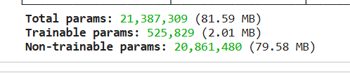
 | Accuracy | Training Accuracy – 97.5%  Validation Accuracy -95.5% | 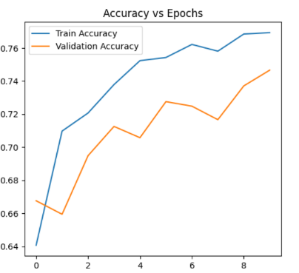
3. | Fine Tunning Result( if Done) | Validation Accuracy -96.06% | 